**Microprocessor Based System Design**

**Task 01**



Spring 2022

CSE-307 Microprocessor Based system Design

Submitted by: **Ashfaq Ahmad**

Registration No: **19PWCSE1795**

Class Section: **B**

“On my honor, as student of University of Engineering and Technology, I have neither given nor received unauthorized assistance on this academic work.”

Student Signature: ______________

Submitted to:

**Dr: Bilal Habib**

**April** 11, 2022

**Department of Computer Systems Engineering**

**University of Engineering and Technology, Peshawar**

## Task # 01:

* Create a delay of 10msec.
* Turn ON an LED for 12msec and then turn OFF for 8msec. Do it continuously.

### Problem Analysis:

### We will start by setting the pin 1 of port 1 that means the LED at pin 1 will get turned ON, after that we will call the delay1 subroutine. Inside delay1 are two nested loops:

* Inner Loop: 2 nop(s)[1 machine cycle each] and 1 djnz[2 machine cycles] instruction.
* Upper loop: 1 djnz instruction.

If we run the inner loop 250 times then it will take 250(1(nop)+1(nop)+2(djnz)) = 1000usec and by running the upper loop 12 times we get 12*1000 = 12000usec = 12ms. After executing these two nested loops program will return after 12ms delay.

### Then by using clr command the LED will turned off and we will call delay2. Inside delay2 again two nested loops:

* Inner Loop: 2 nop(s)[1 machine cycle each] and 1 djnz[2 machine cycles] instruction.
* Upper loop: 1 djnz instruction.

If we run the inner loop 250 times then it will take 250(1(nop)+1(nop)+2(djnz)) = 1000usec and by running the upper loop 8 times we get 8*1000 = 8000usec = 8ms.After executing these two nested loops program will return after 8ms delay.

**Schematic:**

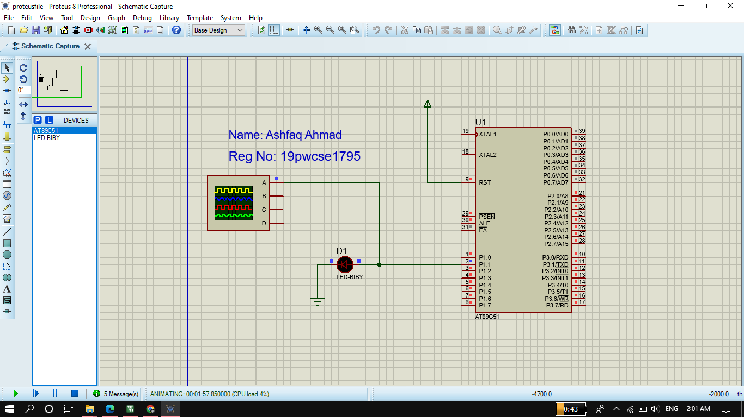

**Oscilloscope Verification:**

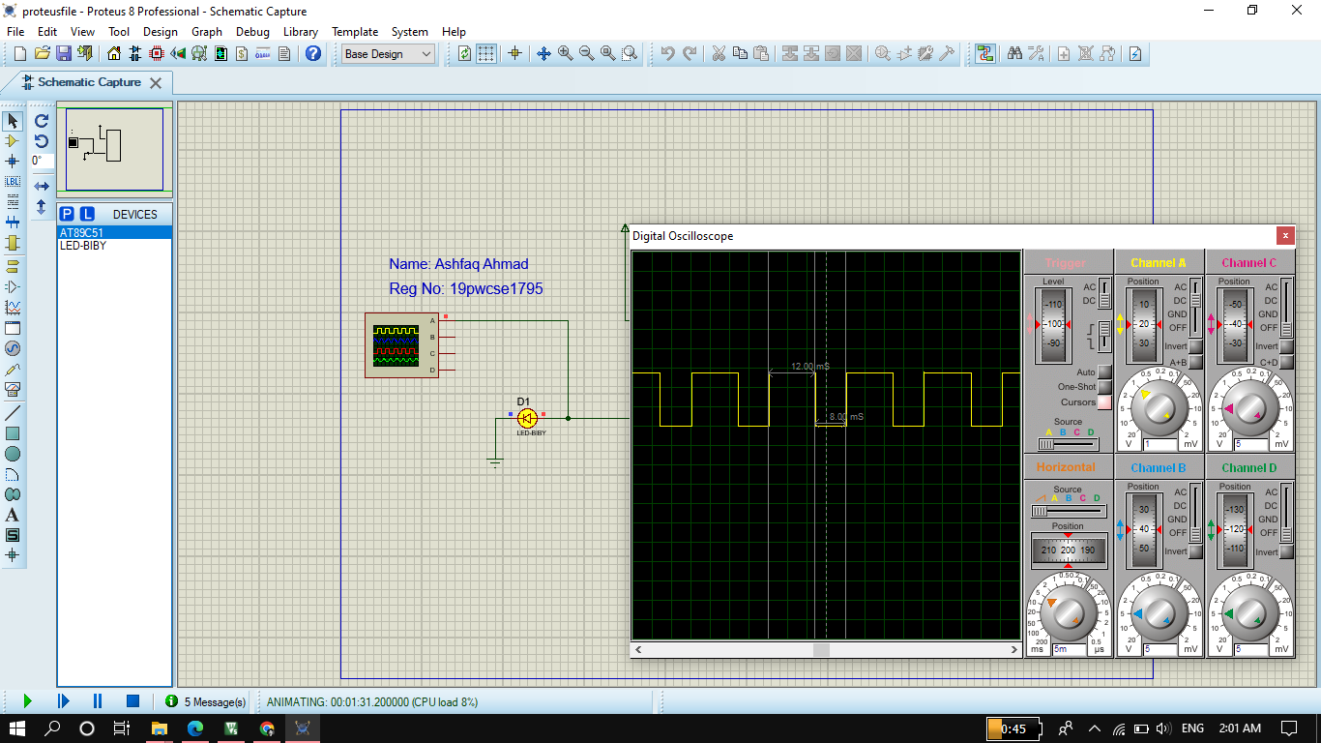

**Code:**

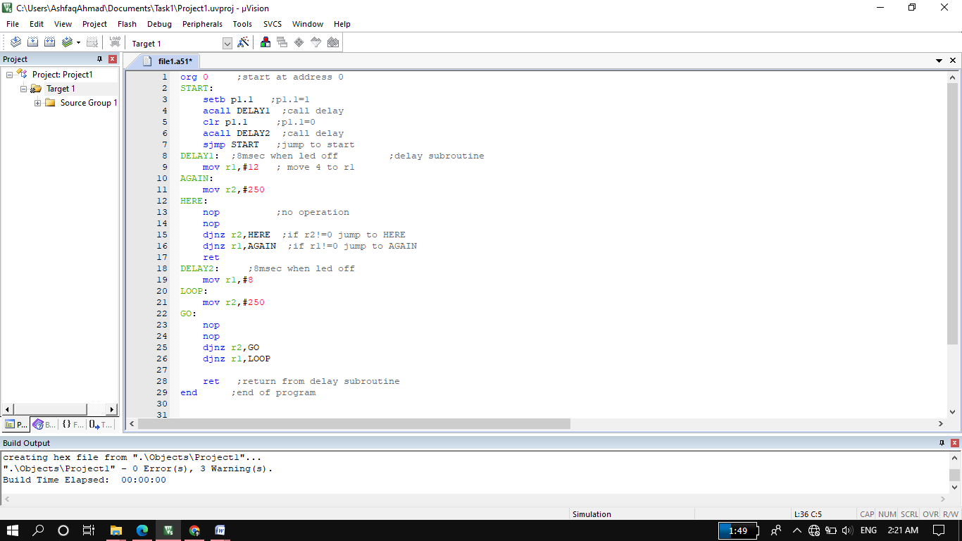

**Block Diagram:**

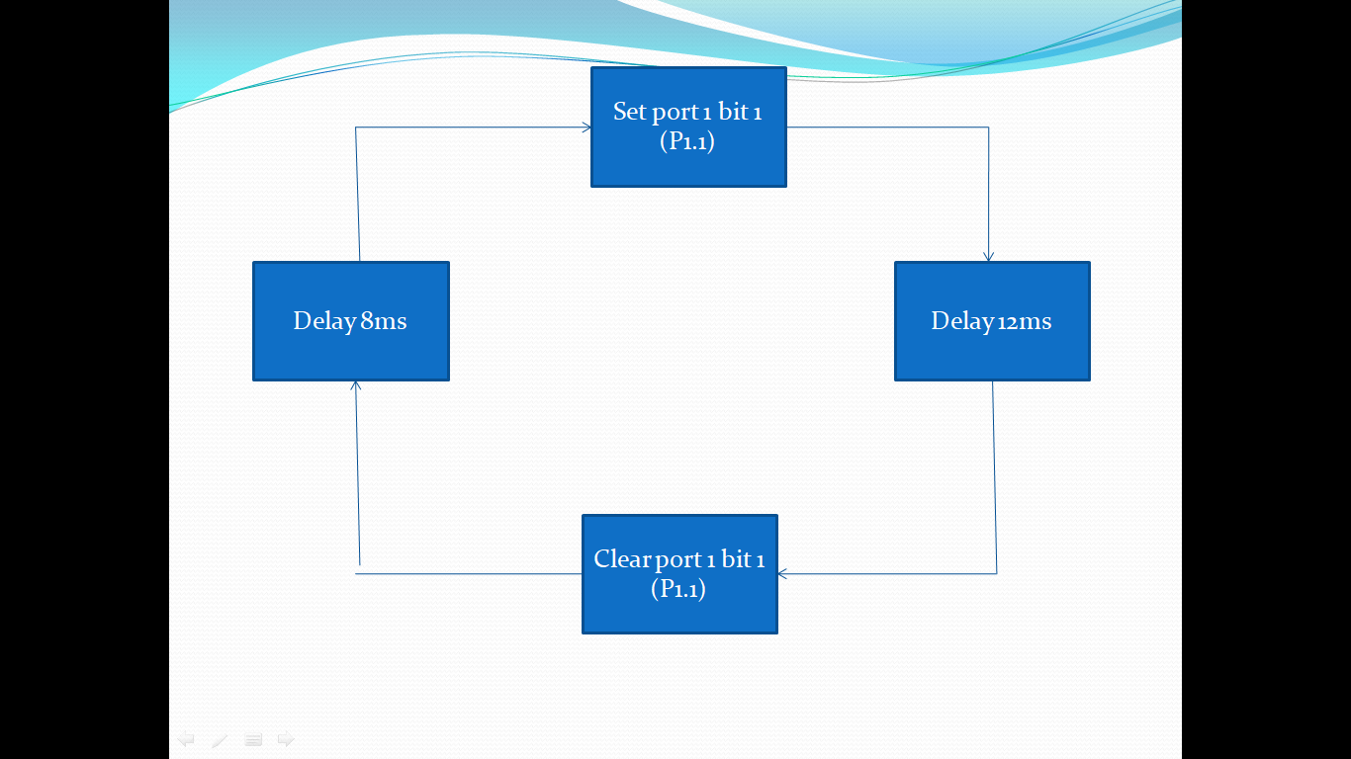

**Flow Chart:**

